Linear Search
Linear Search is a simple searching algorithm that checks each element one by one from the beginning until the required element is found.
PROGRAM:
#include <stdio.h>
int main()
{
int n, target, found = 0;

printf("Enter the number of elements: ");
scanf("%d", &n);

int arr[n];

printf("Enter %d elements:\n", n);
for (int i = 0; i < n; i++)
{
scanf("%d", &arr[i]);
}

printf("Enter the element to search: ");
scanf("%d", &target);

for (int i = 0; i < n; i++)
{
if (arr[i] == target)
{
printf("Element %d found at position %d.\n", target, i + 1);
found = 1;
break;
}
}

if (!found)
printf("Element not found.\n");

return 0;
}

OUTPUT:
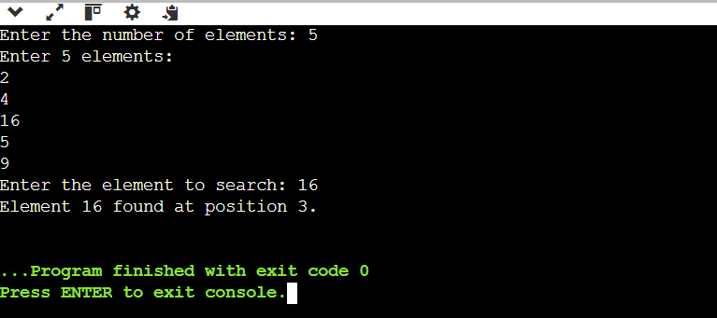

TIME AND SPACE COMPLEXITIES
Case | Time Complexity
Best Case | O(1)
Average Case | O(n)
Worst Case | O(n)
Space Complexity | O(1)

BINARY SEARCH
Binary Search is a searching algorithm that finds an element by repeatedly dividing a sorted array into two halves.
PROGRAM:
#include <stdio.h>
int main()
{
int n, target;

printf("Enter the number of elements: ");
scanf("%d", &n);

int arr[n];

printf("Enter %d elements in ascending order:\n", n);
for (int i = 0; i < n; i++)
scanf("%d", &arr[i]);

printf("Enter the element to search: ");
scanf("%d", &target);

int low = 0, high = n - 1, mid, found = 0;

while (low <= high)
{
mid = (low + high) / 2;

if (arr[mid] == target)
{
printf("Element %d found at position %d.\n", target, mid + 1);
found = 1;
break;
}
else if (target < arr[mid])
high = mid - 1;
else
low = mid + 1;
}

if (!found)
printf("Element not found.\n");

return 0;
}

OUTPUT:
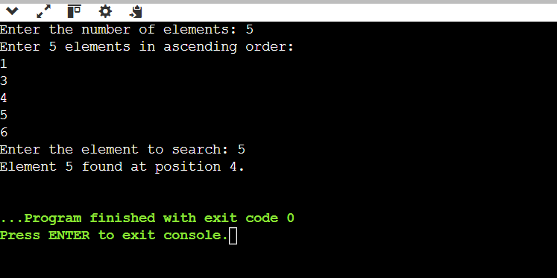

TIME AND SPACE COMPLEXITIES

Case | Time Complexity
Best Case | O(1)
Average Case | O(log n)
Worst Case | O(log n)
Space Complexity (Iterative) | O(1)

